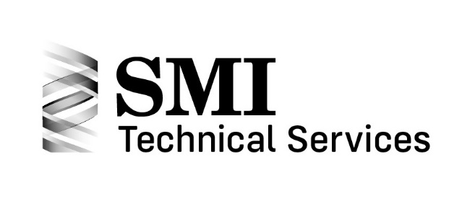

Spring Design 203 – Torsion Spring Design Training Program Webinar

Thursday, December 15, 2022
1:00 – 5:00 pm EST

The Spring Manufacturers Institute will offer our spring design training webinar for torsion springs on Thursday, December 15, 2022 from 1:00 to 5:00 pm EST using GoToMeeting.

Our web-based training programs have been quite popular. High marks have been received from students who attended.

SMI’s Spring Design 203 – Torsion Spring Design webinar combines instruction on basic spring design fundamentals, along with the opportunity for hands-on use of SMI’s Advanced Spring Design 7 (ASD7) software. The course is designed as a focused, real-world spring design training session.

Students will learn:
- The seven-step spring design process
- Definitions and terminology
- Design theory
- Design stress analysis – allowed or advisable
- How to input engineering design data into the ASD7 software
- Important ASD7 tolerancing criteria

Students will have the opportunity to seek opinions and clarification of any torsion spring-related issues which they may have.

This class will benefit the student by increasing their spring design knowledge and their company by having an SMI-trained associate as part of their team.

The training course instructor is Rick Gordon, Technical Director at SMI. Todd Piefer, ASD7 Software expert from UTS, will be available to answer any software and application questions.

The cost for the program is $145.00 for SMI members, $425.00 for non-members with discounts for multiple students.

SMI will provide an ASD7 30-day license to each registered participant.
SPRING DESIGN 203: TORSION SPRINGS WEBINAR
Class Registration Form
December 15, 2022

Name: __________________________________________________________________
Company: _______________________________________________________________
Address: ________________________________________________________________
City: _____________________ State/Province: ______________ Postal Code: _________
E-mail for ASD software download: ____________________________________________
Phone: __________________________________________________________________
Credit Card:
Please charge my credit card Visa MasterCard American Express
Card #: ____________________________________ Exp Date: _____________________
Card holder's name (please print): ____________________________________________
Card holder's signature (required): ____________________________________________
Per student: $145.00 per SMI member
$425.00 per non-member: Second participant - $375.00; Third participant - $325.00; Fourth participant (and beyond) - $275.00
Amount: ________________________________
Name(s) and email(s) of attendees – required for each participant:
_______________________________________
_______________________________________
_______________________________________
_______________________________________

Email credit card information to: dina@smihq.org

Questions? Contact Dina at SMI at dina@smihq.org

Class information: Thursday, December 15, 2022 1:00 to 5:00pm EST
Upon registration, you will be provided with an Advanced Spring Design 30-day license. Completion certificates will also be available upon request.
Deadline: Registration and payment due by Monday, December 12, 2022.

