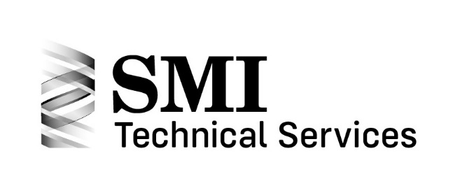
304 Springs – Dimensioning, Tolerancing and Testing Class at SpringWorld

Thursday, Oct. 13, 2022
8:30am – 1:00pm

The Spring Manufacturers Institute will offer spring design training for springs - Dimensioning, Tolerancing and Testing on Thursday, Oct.13, 2022 from 8:30am to 1:00pm

The course will build upon the principles taught in the basic courses, 201 Compression Spring Design, 202 Extension Spring Design, and 203 Torsion Spring Design. It is recommended that students complete the 200 level courses or have equivalent knowledge or experience before signing up for this course.
The course is designed as a focused, real-world spring design training session.

In this course, dimensioning, tolerancing and testing will be discussed for three spring types:
- Helical Compression Springs
- Helical Extension Springs
- Helical Torsion Springs

Students will learn:
- Dimensioning
  - Correct Dimensioning Etiquette
  - Types of Dimensions
  - Engineering Drawing
- Tolerancing
  - The sources of tolerance data included in ASD7 and the Encyclopedia of Spring Design
  - Critical Tolerance Characteristics and Calculations for Each Spring Type
  - Commercial and Precision Quality Factors
  - Tolerancing Do’s and Don’ts - Don’t Over Tolerance
- Testing
  - Good Workmanship Practices
  - Correct Methods and Equipment
  - Performance Characteristics

Students will have the opportunity to seek opinions and clarification of any dimensioning, tolerancing and testing related issues which they may have.

This class will benefit the student by adding to their knowledge of dimensioning, tolerancing and testing of springs, and their company by having an SMI-trained associate as part of their team.

The training course instructor will be Rick Gordon, SMI Technical Director. Technical committee team members who developed the course will also be available to answer questions during the presentation.

The cost for the program is $295.00 for SMI members, $425.00 for non-members. Includes a continental breakfast, coffee, water and snacks.

304 Springs – Dimensioning, Tolerancing & Testing Training Program Class at SpringWorld
Class Registration Form
Thursday, October 13, 2022
8:30am – 1:00pm

Name: __________________________________________________________________
Company: _______________________________________________________________
Address: ________________________________________________________________
City: _____________________ State/Province: ______________ Postal Code: _________
E-mail for all class information: ____________________________________________
Phone: __________________________________________________________________
Credit Card:
Please charge my credit card Visa MasterCard American Express
Card #: ____________________________________ Exp Date: _____________________
Card holder's name (please print): ____________________________________________
Card holder's signature (required): ____________________________________________
Per student: $295.00 per SMI member
$425.00 per non-member
Students must bring own laptop computer. Class will be held in room 40 of the Rosemont Convention Center. Includes a continental breakfast, coffee, water and snacks.
Amount: ________________________________
Name(s) and emails of attendees:
_______________________________________
_______________________________________
_______________________________________

Email credit card information to: dina@smihq.org
Questions? Contact Dina at SMI at dina@smihq.org

Upon registration, you will be provided with a set of class presentation slides. Completion certificates will also be available upon request.
Deadline: Registration and payment due by Monday, October 3, 2022. Seating is limited: only the first 20 registrants will be accepted into the class.

