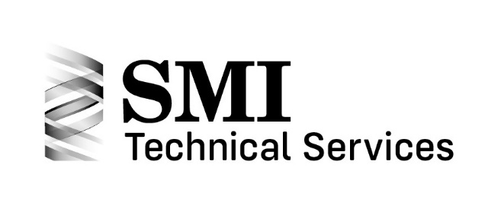
Spring Design 301 Springs – Fatigue Training Program Class at SpringWorld

Wednesday, Oct. 12, 2022
8:30am – 1:00pm

The Spring Manufacturers Institute will offer our spring design training class for Springs - Fatigue on Wednesday, Oct. 12, 2022 from 8:30am to 1:00pm.

The course will build upon the principles taught in the basic courses, 201 Compression Spring Design, 202 Extension Spring Design, and 203 Torsion Spring Design. It is recommended that students complete the 200 level courses or have equivalent knowledge before signing up for this course.
The course is designed as a focused, real-world spring design training session.

Students will learn:
- The causes and mechanisms of failure in springs
- The definition of fatigue and three stage fatigue failure process
- The four key factors of fatigue
- Fatigue design considerations for a successful project utilizing the SMI seven step spring design process
- Goodman diagram interpretation and how to input engineering fatigue test data into the ASD7 software
- Fatigue failure analysis methodology overview

Students will have the opportunity to seek opinions and clarification of any fatigue-related issues which they may have.

This class will benefit the student by increasing their knowledge of fatigue of springs, and their company by having an SMI-trained associate as part of their team.

The training course instructor is Richard Gordon, Technical Director at SMI. Rick has many years of experience in the wire industry and SMI, conducting failure analysis projects on springs. He currently oversees SMI’s failure analysis program.

The cost for the program is $295 for SMI members and $425 for nonmembers, and includes a continental breakfast, coffee, water and snacks.

301 Springs – Fatigue Training Class at SpringWorld
Class Registration Form
Wednesday, Oct. 12, 2022
8:30am – 1:00pm

Name: __________________________________________________________________
Company: _______________________________________________________________
Address: ________________________________________________________________
City: _____________________ State/Province: ______________ Postal Code: _________
E-mail for all class information: ____________________________________________
Phone: __________________________________________________________________
Credit Card:
Please charge my credit card Visa MasterCard American Express
Card #: ____________________________________ Exp Date: _____________________
Card holder's name (please print): ____________________________________________
Card holder's signature (required): ____________________________________________
Per student: $295.00 per SMI member
$425.00 per non-member
Students must bring own laptop computer. Class will be held in room 40 of the Rosemont Convention Center. Includes a continental breakfast, coffee, water and snacks.
Amount: ________________________________
Name(s) and emails of attendees:
_______________________________________
_______________________________________
_______________________________________

Email credit card information to: dina@smihq.org
Questions? Contact Dina at SMI at dina@smihq.org

Upon registration, you will be provided with a set of class presentation slides. Completion certificates will also be available upon request.
Deadline: Registration and payment due by Monday, October 3, 2022. Seats are limited: Only the first 20 registrants will be accepted.

